Flow- File Uploads as Attachments to SharePoint
To send entry data for a new entry while including the uploaded files as attachments to a SharePoint list:

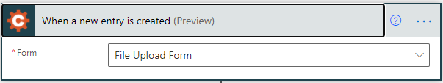
1. Select "When a New Entry is Created" as the Trigger within Power Automate and choose the form's name from the drop-down menu.

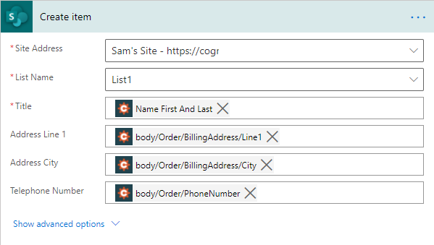
2. Select "Create Item" as the first Action. Select the Site Address and List Name in SharePoint where the attachments will be sent. Then, choose which fields' values should be sent to the columns in the list:

3. ​Click “New Step” and Choose “Add attachment” (in SharePoint) as the action.
4. Choose the same Site Address and List Name as the previous step.
5. Choose “ID” from the dynamic content options as the “Id”. This will link the attachment to the item that was just created.
6. Choose “Name” from the dynamic content options for File Name. **There will be multiple “Name” options in the list. This will match the order of the fields on the form. So, the upload field that is highest up (first) on the form in Cognito, will be first in the list. (If the Upload Field is inside a section, the name of the section will need to be referenced first when looking for the Name and Content values.) **After the File Name is chosen, this will put the Add Attachment into a Apply to Each control. This should happen, so don’t worry. Just open the Add Attachment action back up to finish setting up the fields.
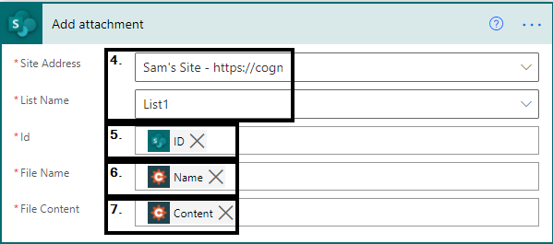
7. Choose “Content” from the dynamic content options for File Content. **The same order rule applies to the Content options as the Name options as far as there being multiple options.

The Flow will look like the one below when it is set up:
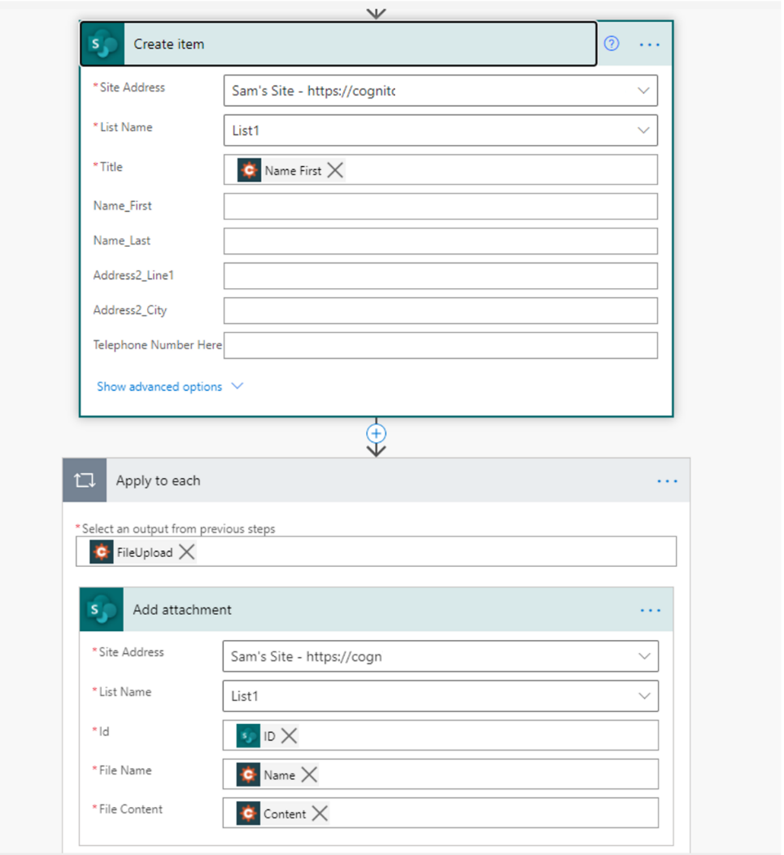
Finally, save your Flow and submit a test entry on your form to make sure all fields and the uploaded fields are sent over correctly.
If you have multiple File Upload fields on your form, the additional steps will be needed:

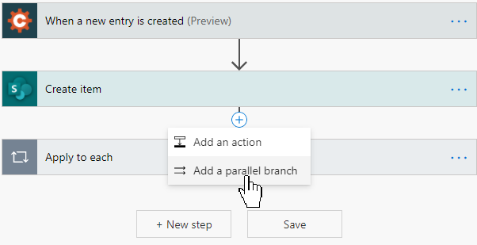
8. Click the plus sign above the Apply to Each action and choose "Add a parallel branch" or “Add an Action”, either will work, but will just be displayed differently within the flow.
9. In the parallel branch that is created, create the same settings as the other branch, but choose the second File Upload "Name" option and "Content".

The whole flow should look like this, when done:
​



